**NEPAL COLLEGE OF INFORMATION TECHNOLOGY**

**Balkumari, Lalitpur**



**A Lab Report**

**On**

**Subject:- Web Technology**

**Lab Report # _4__.**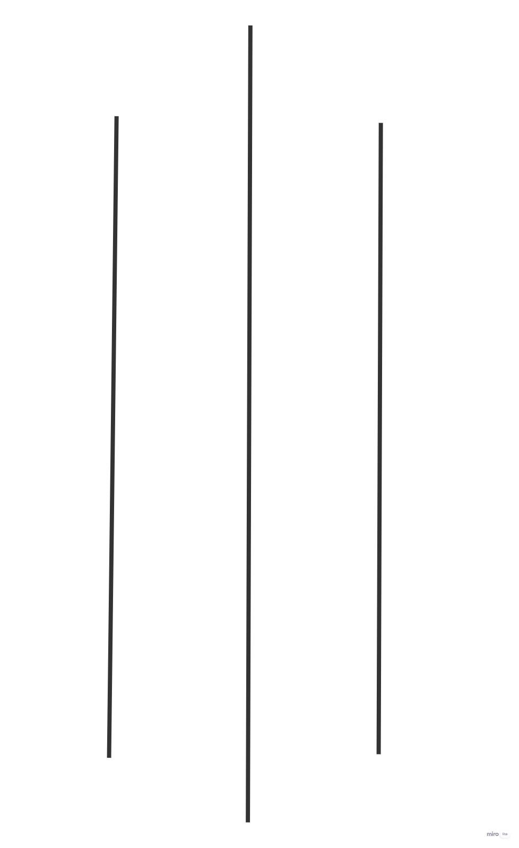

**Title: - selector**

**Submitted by:- Submitted to:-**

**Name : - Abiral Chaudhary Instructor: - Simanta Kasaju**

**Roll No:- 221702 Department :- software**

**Faculty: - science and technology Submission Date:2080/03/09**

**Semester:-II**

## Selector(attribute):

The [attribute] selector is used to select elements with a specified attribute.

**Question:1)**

**Code:**

**<!DOCTYPE html>**

**<html lang="en">**

**<head>**

**<title>Example:Nested</title>**

**<style>**

**table,td,th{**

**border: 1px solid black;**

**border-collapse: collapse;**

**}**

**</style>**

**</head>**

**<body>**

**<p align="center">Example:Nested</p>**

**<table >**

**<tr>**

**<th colspan="2">CI </th>**

**<th >All Genders</th>**

**<th colspan="2">By Gender**

**<table > <tr>**

**<th>Males</th>**

**<th>females</th>**

**</tr>**

**<tr>**

**<td>874895</td>**

**<td>981279</td>**

**</tr>**

**</table></th>**

**</tr>**

**<tr>**

**<td>Rural</td>**

**<td>651334</td>**

**<td>23453</td>**

**<td colspan="2">213534</td>**

**</tr>**

**</table>**

**</body>**

**</html>**

**Screenshot:**

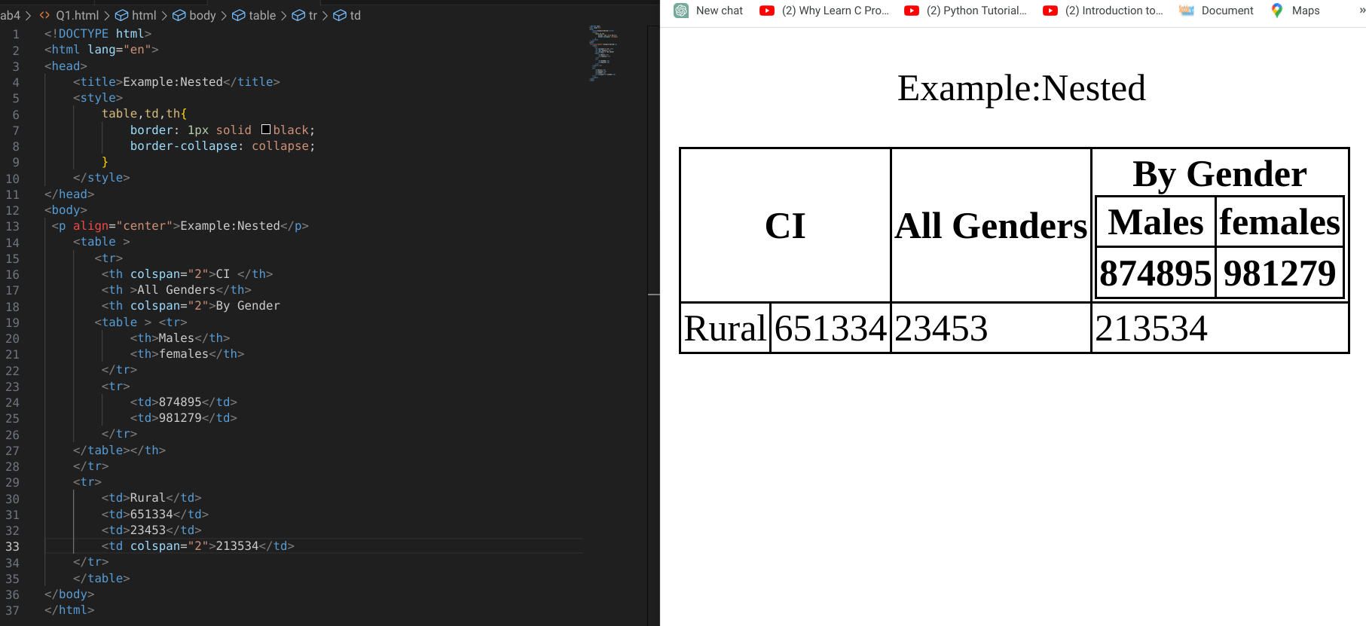**SQuestion:2)**

**Question:2)**

**Code:**

**<!DOCTYPE html>**

**<html lang="en">**

**<head>**

**<title>Document</title>**

**</head>**

**<body>**

**<table border="1">**

**<tr>**

**<th rowspan="2">BCA</th>**

**<th colspan="2">Total Student</th>**

**<th rowspan="2">Inside Valley</th>**

**<th rowspan="2">Outside Valley </th>**

**</tr>**

**<tr>**

**<th>Male</th>**

**<th>feMale</th>**

**</tr>**

**<tr>**

**<td>First sem</td>**

**<td>20</td>**

**<td>20</td>**

**<td>60%</td>**

**<td>40%</td>**

**</tr>**

**<tr>**

**<td>third sem</td>**

**<td>25</td>**

**<td>25</td>**

**<td>50%</td>**

**<td>50%</td>**

**</tr>**

**<tr>**

**<td>fifth</td>**

**<td>10</td>**

**<td>10</td>**

**<td>70%</td>**

**<td>30%</td>**

**</tr>**

**<td colspan="5"> <table border="1" align="centre">**

**<tr>**

**<caption><b>Total</b></caption>**

**<th>Male</th>**

**<th>Female</th>**

**<th>Inside Valley</th>**

**<th>Outside Valley</th>**

**</tr>**

**<tr>**

**<td>55</td>**

**<td>55</td>**

**<td>60%</td>**

**<td>40%</td>**

**</tr>**

**</table></td>**

**</table>**

**</body>**

**</html>**

**Screenshot:**

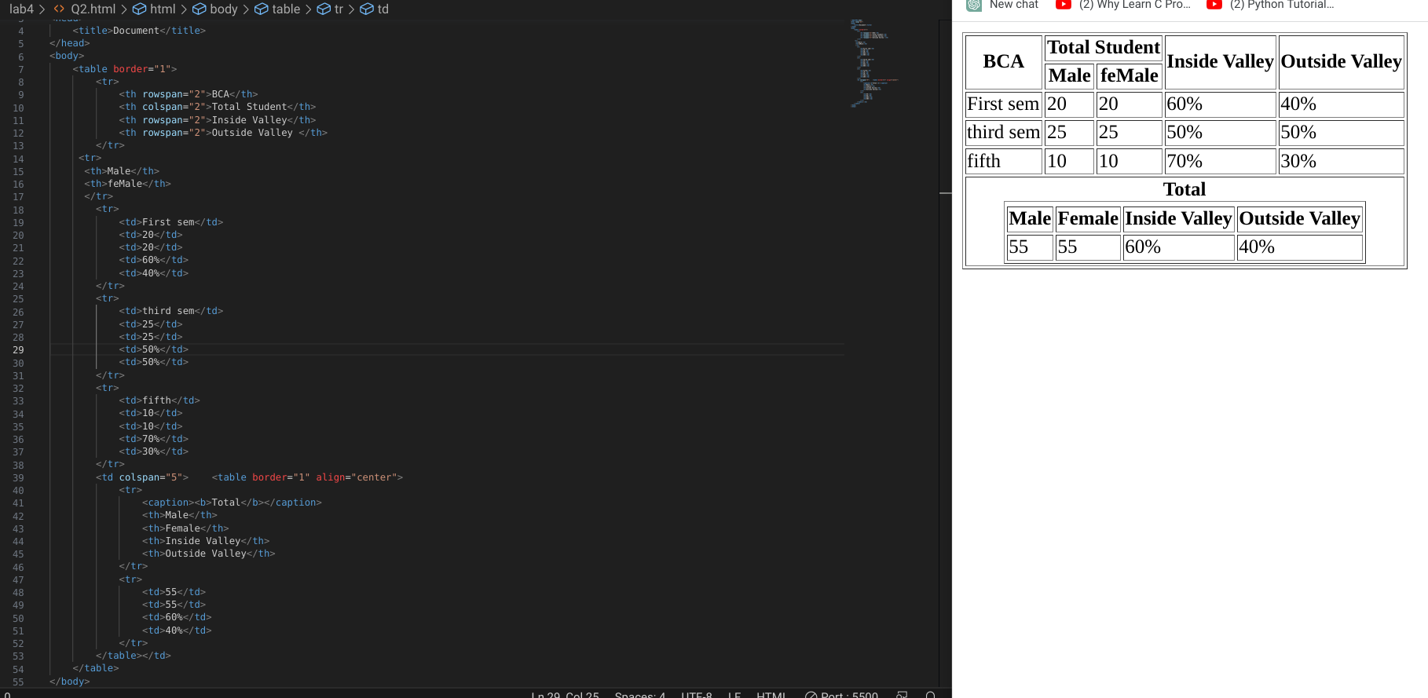

**Question:3)**

**Code:<!DOCTYPE html>**

**<html lang="en">**

**<head>**

**<title>Document</title>**

**<style>**

**#r{ color: blue;}**

**body{background-image:url(ncit.jpg );**

**background-repeat: no-repeat;**

**background-size: cover; }**

**.A{background-color: aqua;}**

**.s{background-color: red;}**

**.B{background-color: fuchsia;}**

**.C{ background-color: lightgreen;}**

**.D{background-color: chartreuse;}**

**.E{background-color: lightpink;}**

**.f{background-color:rgb(10, 153, 153);}**

**#A{background-color: orange;}**

**.G{background-color: bisque ;}**

**.H{background-color: blue;}**

**</style>**

**</head>**

**<body >**

**<p id="r" align="center" ><u>Ncit</u></p>**

**<p align="center">DEPARTMENT OF SOFTWARE**

**<br>EFFECTIVE FROM:01-07-2022</p>**

**<pre align="center"> semster:2 class mentor:<u> Er.Simanta Khasaju </u> </pre>**

**<table border="1" align="center" width="1000px" height="800px">**

**<tr>**

**<th id="A" >Day/Periods</th>**

**<th class="E" >1 <br>06.30-07.30</th>**

**<th class="E" >2 <br>07.30-08.30</th>**

**<th class="E" >3 <br>08.30-09.00</th>**

**<th class="E" >4 <br>09.00-10.00</th>**

**<th class="E" >5 <br>10.00-11.00</th>**

**<th class="E" >6 <br>11.00-12.00</th> </tr>**

**<tr>**

**<td class="f">Monday</td>**

**<td class="A">Web technology</td>**

**<td class="D" ; >DSA</td>**

**<td class="s">Break</td>**

**<td class="C" >Java</td>**

**<td class="G">Probability</td>**

**<td class="B">SAD</td>**

**</tr> <tr>**

**<td class="f">Tuesday</td>**

**<td class="A"colspan="2">Web technology</td>**

**<td class="s">Break</td>**

**<td class="C" colspan="2">Java</td>**

**<td class="B">SAD</td>**

**</tr> <tr>**

**<td class="f">Wednesday</td>**

**<td class="D" colspan="2">DSA</td>**

**<td class="s">Break</td>**

**<td class="G" colspan="2">probability</td>**

**<td class="B">SAD</td>**

**</tr><tr>**

**<td class="f">Thursday</td>**

**<td class="B" colspan="2">SAD </td>**

**<td class="s">Break</td>**

**<td class="H" colspan="4">Java//Web tech lab</td>**

**</tr> <tr>**

**<td class="f">friday</td>**

**<td class="E" colspan="2">Extra curriculam</td>**

**<td class="s">Break</td>**

**<td class="H" colspan="4">DSA//Probability lab</td>**

**</tr> <tr>**

**<td class="f">Saturday</td>**

**<td class="A">Web technology</td>**

**<td class="D" >DSA</td>**

**<td class="s">Break</td>**

**<td class="C" >Java</td>**

**<td class="G">Probability</td>**

**<td class="B">SAD</td>**

**</tr></table>**

**</body>**

**</html>**

**Screenshot:**

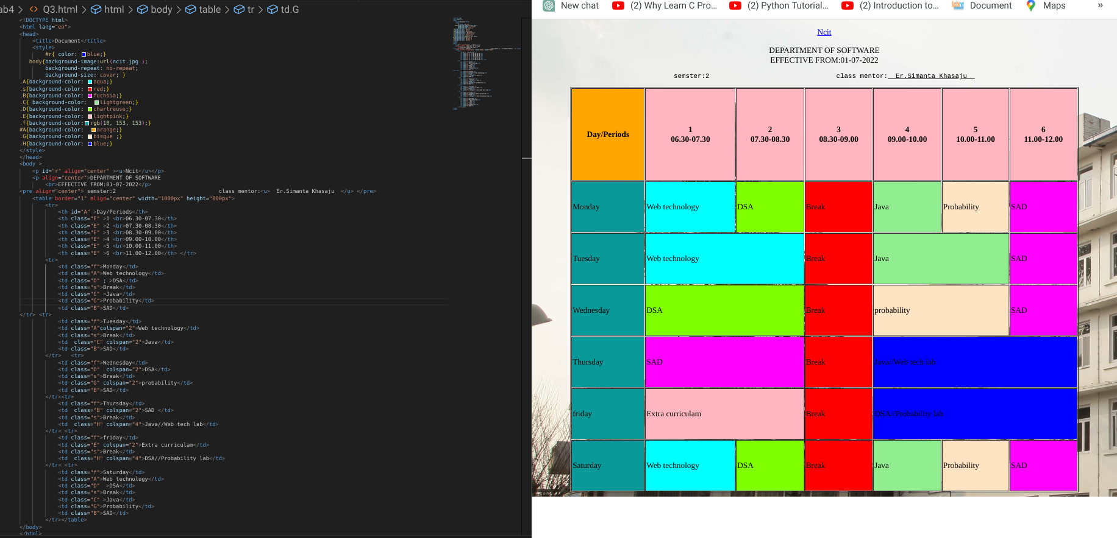

**Question:5)**

**Code:<!DOCTYPE html>**

**<html lang="en">**

**<head>**

**<meta charset="UTF-8">**

**<meta name="viewport" content="width=device-width, initial-scale=1.0">**

**<title>Document</title>**

**<style>**

**h1{**

**colour: red;**

**}**

**</style>**

**</head>**

**<body>**

**<h1>Top 5 richest people </h1>**

**<table >**

**<tr><td rowspan="2" >**

**<marquee behaviour="scroll" direction="right">**

**<img src="jeff.jpg" alt="" width="100">**

**</marquee></td>**

**<th><ol>**

**<li >Jeff Bezos</li>**

**</ol></th>**

**<th rowspan="2">**

**<p>want to know more about </p>**

**<a href="https://en.wikipedia.org/wiki/Jeff_Bezos"> Jeff_Bezos</a>**

**</th></td></tr>**

**<tr><td><ul>**

**<li>Age:57</li>**

**<li>Residence:Seattle</li>**

**<li>founder and CEO:Amazon</li>**

**<li>Net Worth:$177 billion</li>**

**</ul></td></tr>**

**<tr><td rowspan="2">**

**<marquee behaviour="scroll" direction="right">**

**<img src="elon.jpg" alt="" width="100">**

**</marquee>**

**<th><ol start="2">**

**<li>ELON Musk</li>**

**</ol></th></td>**

**<th rowspan="2">**

**<p>Want to know more about</p>**

**<a href="https://en.wikipedia.org/wiki/Elon_Musk"> Elon_Musk</a>**

**</th></tr>**

**<tr><td><ul>**

**<li>Age:49</li>**

**<li>Co Founder and CEO:Tesla</li>**

**<li>Net Worth:$151 billion</li>**

**</ul></td></tr>**

**<tr><td rowspan="2">**

**<marquee behaviour="scroll" direction="right">**

**<img src="Bernad.jpg" alt="" width="100">**

**</marquee>**

**<th><ol start="3">**

**<li>Bernard Arnault</li>**

**</ol></th>**

**<th rowspan="2">**

**<p>Want to know more about</p>**

**<a href="https://en.wikipedia.org/wiki/Bernard_Arnault">Bernard_Arnault</a>**

**</th></td ></tr>**

**<tr><td><ul>**

**<li>Age:72</li>**

**<li>Residence:Paris</li>**

**<li>CEO and Chair:LVMH(LVMUY)</li>**

**<li>Net Worth:$150 billion</li>**

**</ul> </td></tr>**

**<tr><th rowspan="2">**

**<marquee behaviour="scroll" direction="right">**

**<img src="Bill.jpg" alt="" width="100">**

**</marquee>**

**<th><ol start="4">**

**<li>Bill Gates</li>**

**</ol></th>**

**<th rowspan="2">**

**<p>Want to know more about</p>**

**<a href="https://en.wikipedia.org/wiki/Bill_Gates">Bill_Gates</a>**

**</th></td></tr>**

**<tr><td><ul>**

**<li>Age:65</li>**

**<li>Residence:Medina,Wash</li>**

**<li>Co Founder:Microsoft Corp.(MSFT)</li>**

**<li>Net Worth:$124 billion</li>**

**</ul></td></tr>**

**<tr><th rowspan="2">**

**<marquee behaviour="scroll" direction="right">**

**<img src="mark.jpeg" alt="" width="100">**

**</marquee>**

**<th><ol start="5">**

**<li>Mark Zuckerberg</li>**

**</ol> </th>**

**<th rowspan="2">**

**<p> want to know more about</p>**

**<a href="https://en.wikipedia.org/wiki/Mark_Zuckerberg">Mark_Zuckerberg</a>**

**</th></th></tr>**

**<tr><td><ul>**

**<li>Author:Harry Potter</li>**

**<li>price:950</li>**

**<li>Publisher:jyothi publishers</li>**

**</ul></td></tr>**

**</table>**

**</body>**

**</html>**

**Screenshot:**

